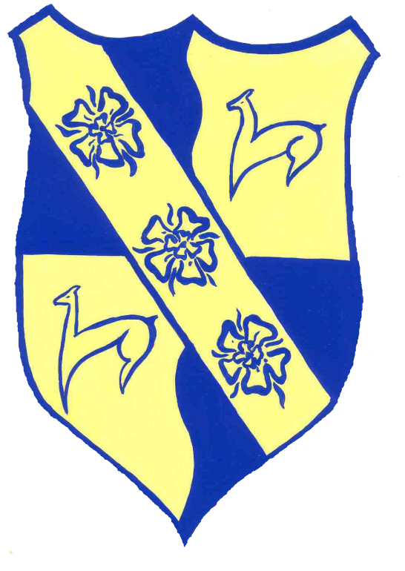

Inner Wheel Arnhem Geldria

